Test Plan for VWO A/B Testing Platform

1. Introduction
This test plan document outlines the testing strategy for app.vwo.com, a leading A/B testing and conversion optimization platform. The plan ensures all features meet quality standards while maintaining data accuracy and performance reliability.

2. Objectives
- Validate end-to-end experiment creation and execution workflows
- Ensure statistical accuracy in test results and reporting
- Verify platform stability under varying traffic loads
- Maintain cross-browser/device compatibility
- Confirm data security and privacy compliance

3. Scope

Included Features
Module | Key Components
User Management | Login, SSO, Role-based access
Experiment Console | A/B, Multivariate, Split URL tests
Targeting Engine | Geo, Device, Behavioural rules
Analytics | Real-time dashboards, Statistical significance
Excluded Features
- Zoho chat support widget
- Legacy reporting modules
- Third-party API integrations

4. Test Environment

Technical Specifications-
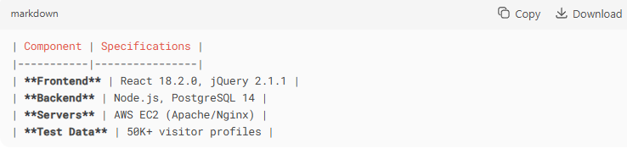

Browser Matrix-

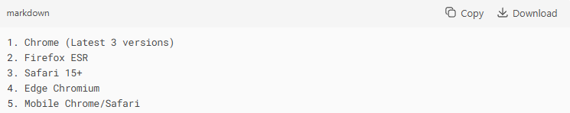

5. Test Strategy
Testing Methodology

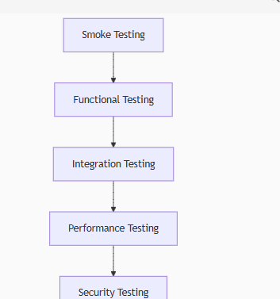

Test Design Techniques
- Equivalence Partitioning - Input validation ranges
- Boundary Analysis - Min/Max variation weights
- Decision Tables - Complex targeting rules
- State Transition - Experiment lifecycle

6. Defect Management
Severity Classification-

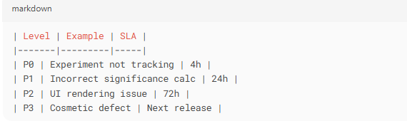

Workflow
- Log in JIRA with reproduction steps
- Assign to component owner:
  - Frontend → Devesh
  - Backend → Sonal
  - Infrastructure → Prajeeth
- Verify fixes in corresponding environment

7. Test Schedule

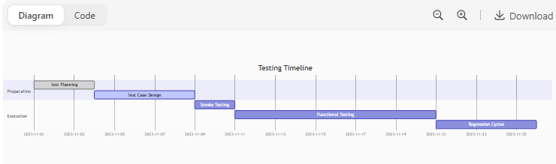

8. Entry/Exit Criteria
Test Execution
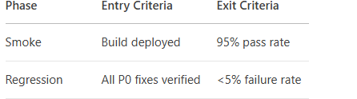

9. Risk Management

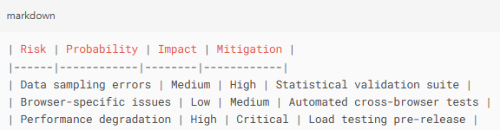
10. Tools
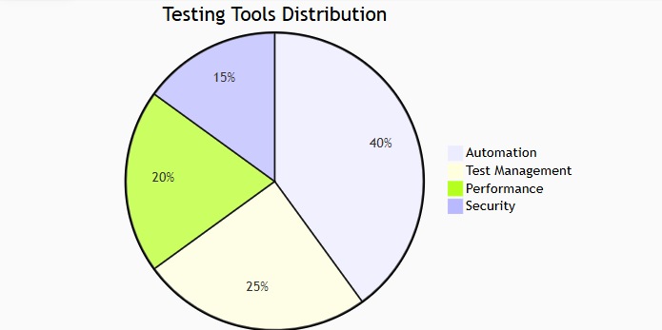

11. Approvals
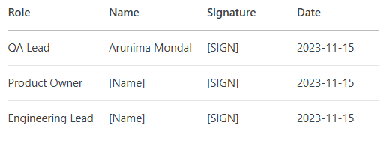
This test plan provides complete coverage for VWO's experimentation platform while maintaining focus on data accuracy and user experience. The document will be reviewed quarterly and updated per feature releases.

